Shared Storage Creation

Login Host

Select the VM 🡪 Actions🡪 Edit Settings.

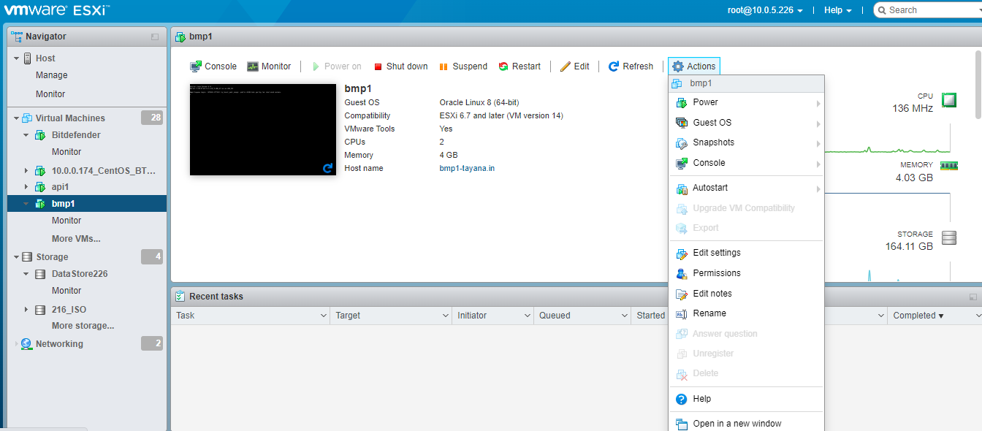

Edit Settings 🡪 Add SCSI Controller 🡪

Open the SCSI Controller 🡪 SCSI Bus Sharing 🡪 Select Virtual🡪 Save.

Select Action 🡪 Edit Settings

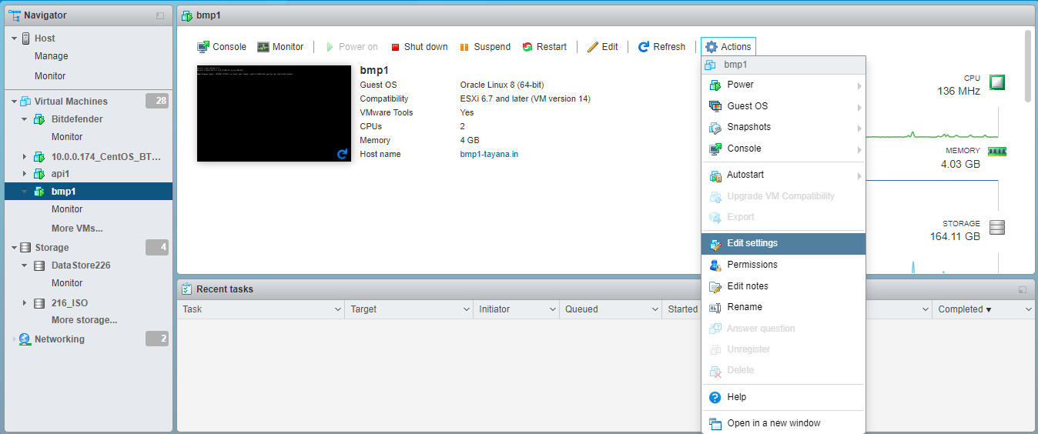

Add New Standard Hard Disk 🡪

Enter Hard Disk Space in Eg : 10 GB

